Phase-2-Week-7 – Home Assignment - Sanjeevi:
Scenario 1
Metrics- Faithfulness
Input (User question): What is selenium
Actual output (Models Actual output): Selenium is a web automation framework for testing web application
Retrieval context -Selenium is a web automation framework for testing web application
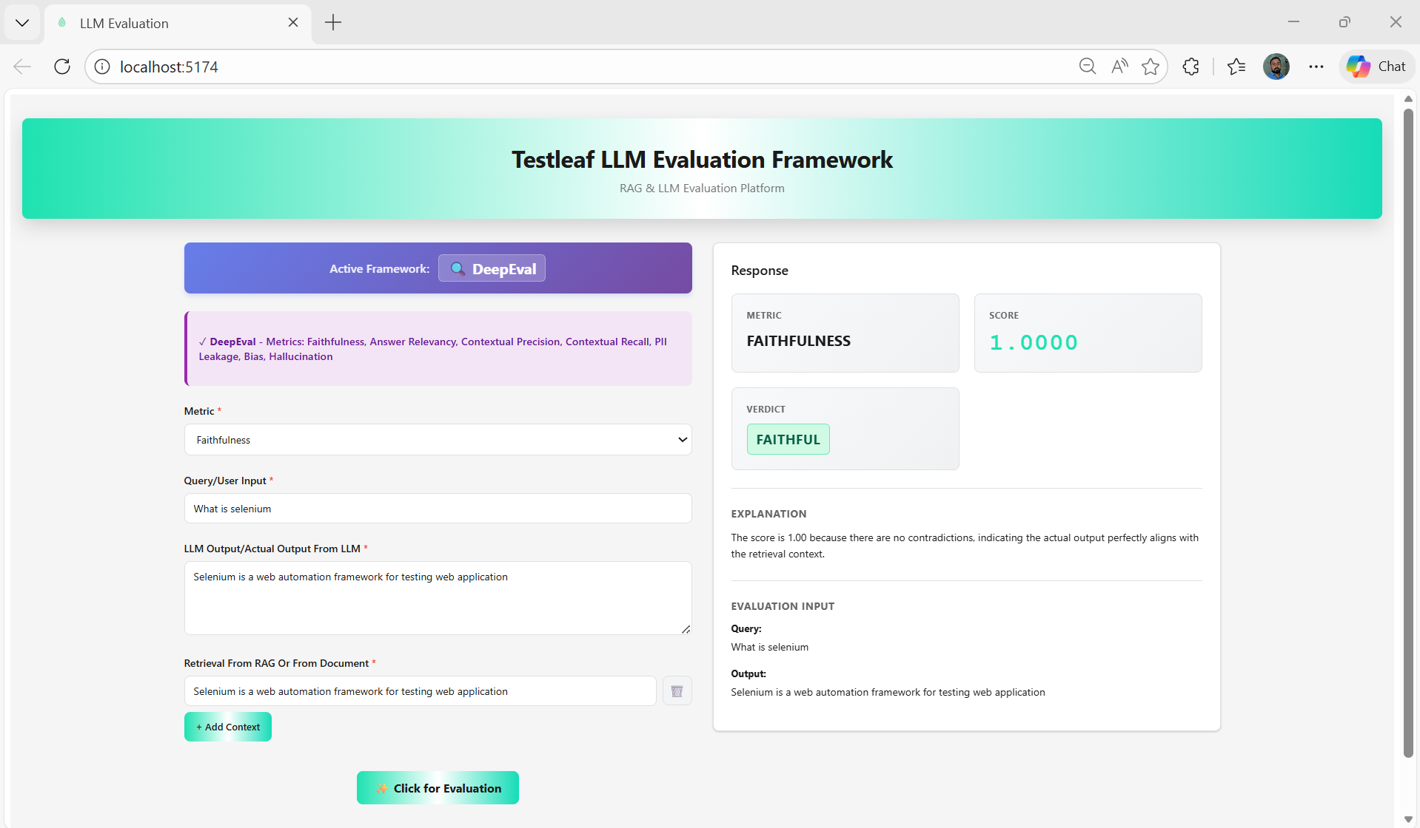

Scenario 2
Metrics-Faithfulness
Input: What is selenium
Actual output (Models Actual output): Selenium is a web automation framework for testing web application
Retrieval context-Selenium is a rare element
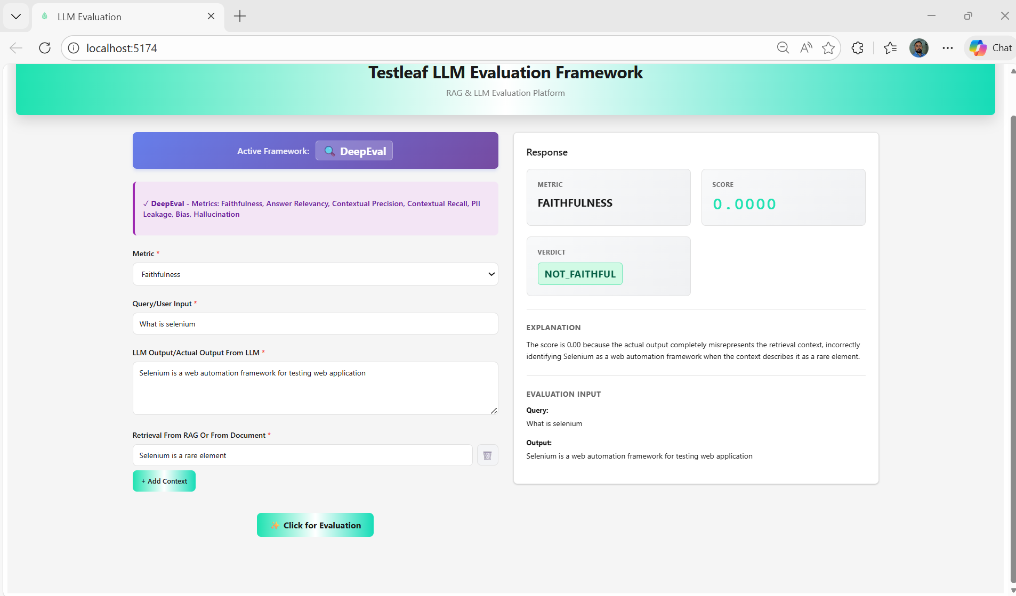

Scenario 3:
Metrics-Faithfulness
Input (User question): What is selenium
Actual output (Models Actual output): Selenium is a automation framework for testing web and desktop application
Retrieval context -Selenium is a web automation framework for testing web application (From Mongo)

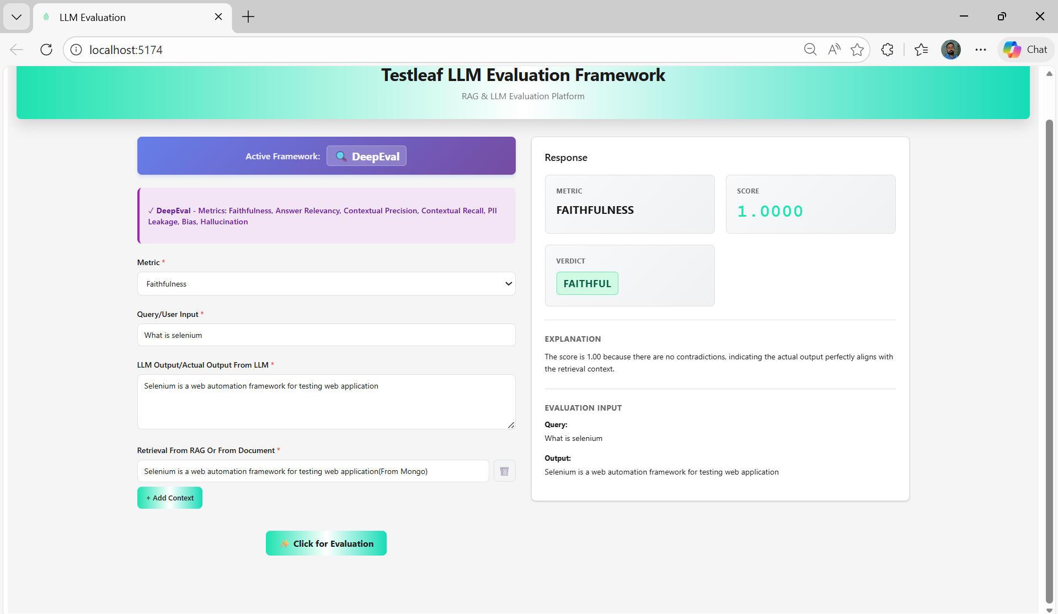

Scenario 4
Baahubali is brave.
Baahubali fights Bhallaladeva.
Baahubali is brave.
Baahubali fights Bhallaladeva.
Baahubali goes to space.

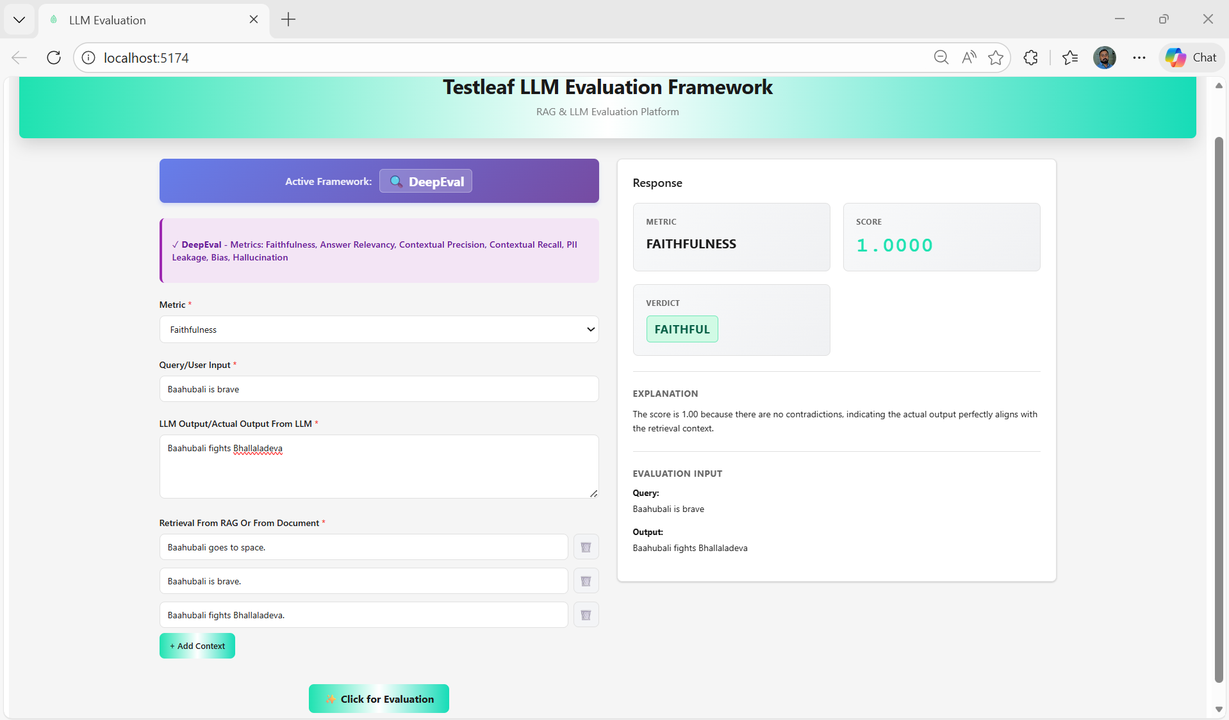

Scenario 5
Velu is a Kabaddi player.
Velu saves Dhanalakshmi from Muthupandi.
Velu hides her in Chennai.
-----------
Velu is a Kabaddi player.
Velu saves Dhanalakshmi from Muthupandi.
Velu hides her in Chennai.
Velu later becomes the Chief Minister of Tamil Nadu.

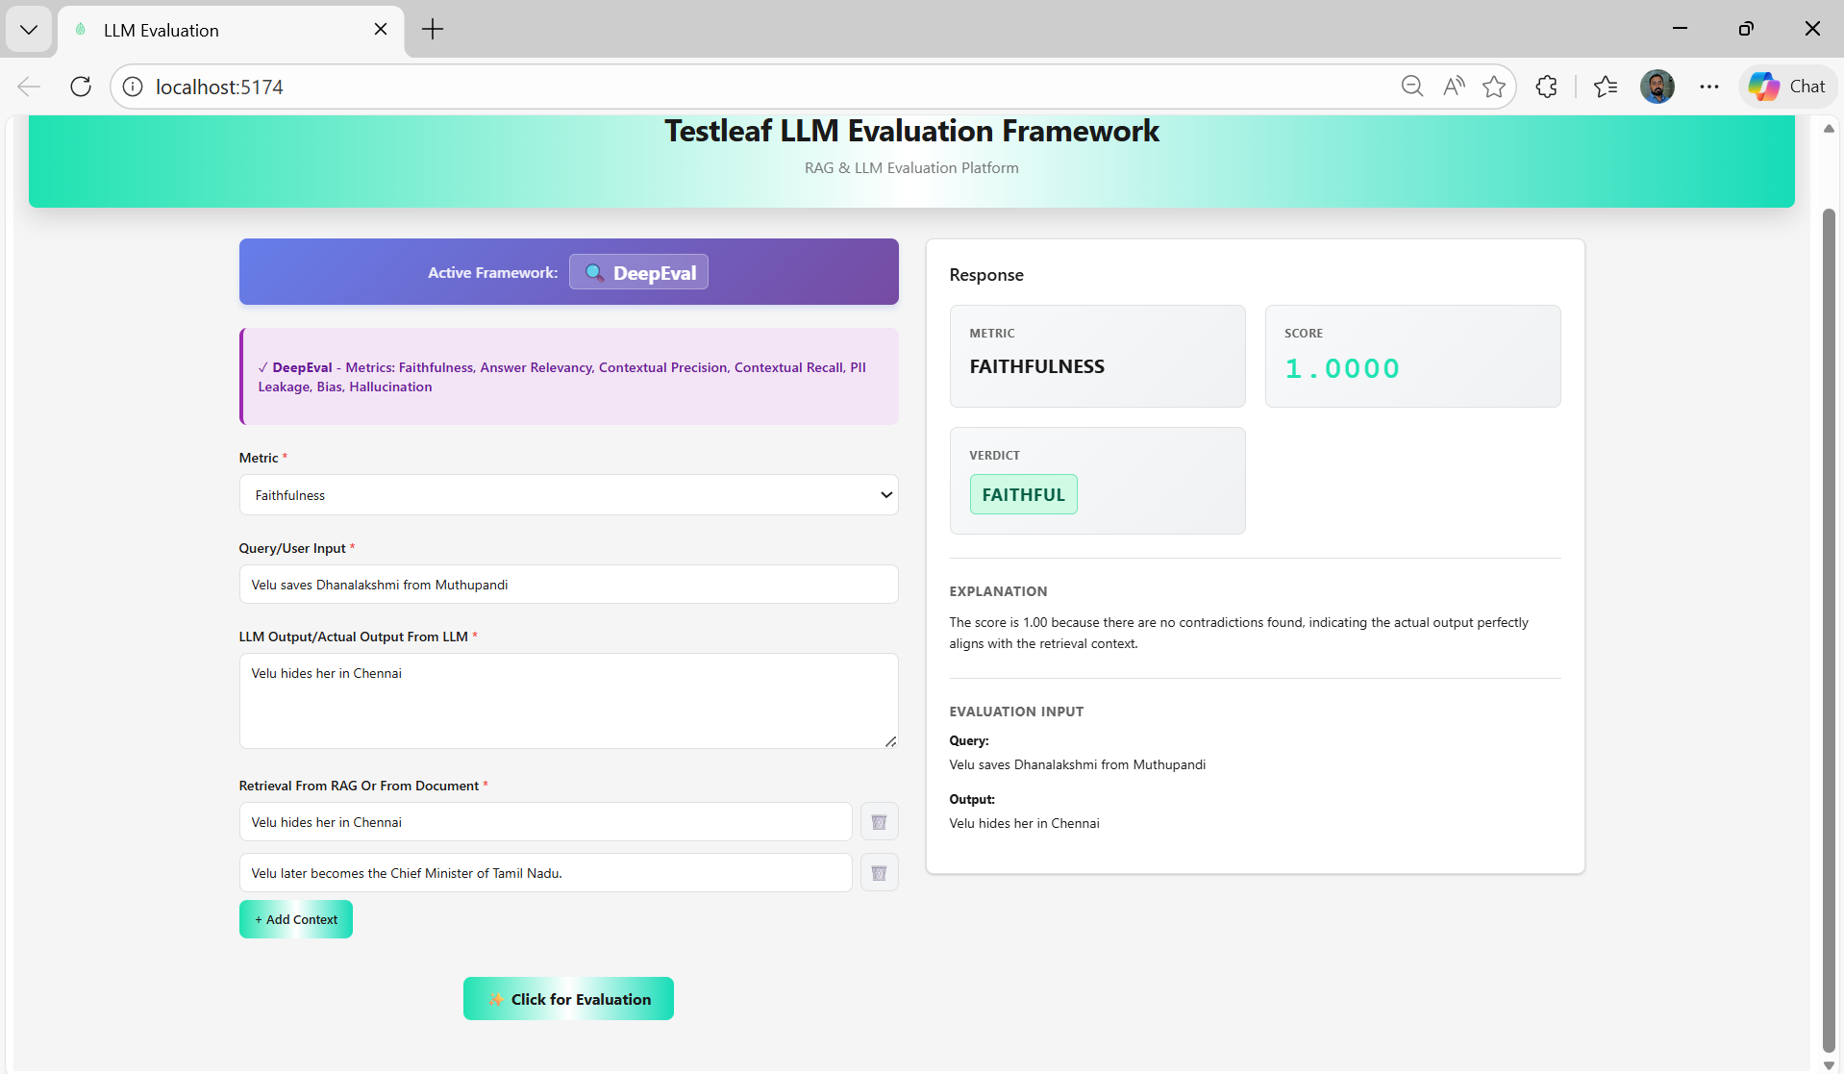

Explore few more scenarios on my own:
Scenario: 6
Which city is the headquarters of Microsoft located in?
Microsoft's headquarters is located in Redmond, Washington.
Microsoft Corporation is an American technology company headquartered in Redmond, Washington.
The company was founded by Bill Gates and Paul Allen in 1975.

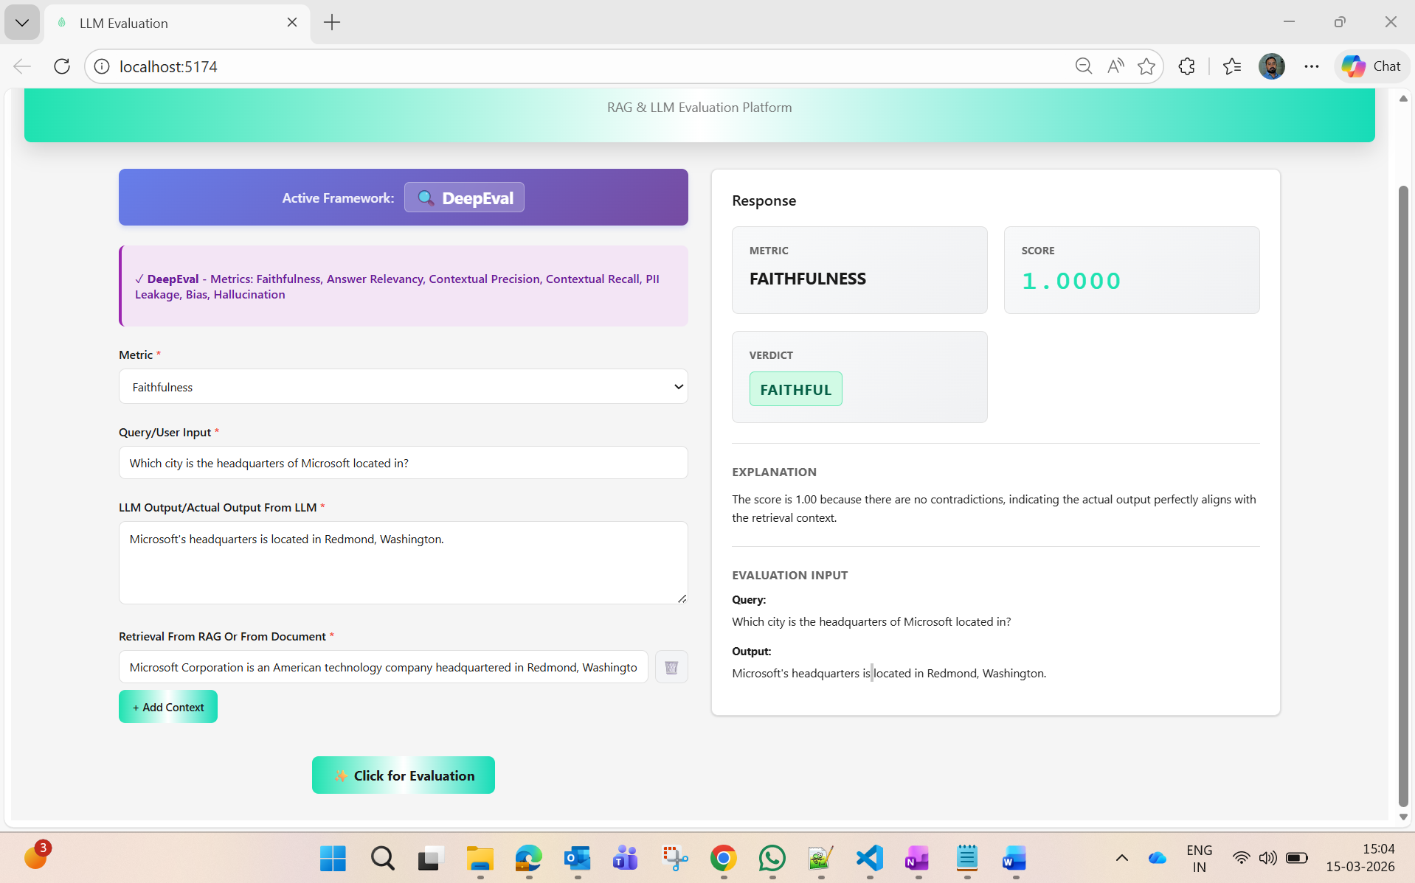

Correct Response:
The response directly matches the information present in the retrieval context.
The output states that Microsoft’s headquarters is in Redmond, Washington, which
is explicitly mentioned in the provided context. No additional or contradictory
information is introduced.

Scenario: 7 Unfaithful (Hallucinated) Response
What is the capital city of Brazil?
The capital city of Brazil is Rio de Janeiro.
Brasília is the capital city of Brazil. It became the capital in 1960.
Rio de Janeiro was the capital of Brazil before Brasília.

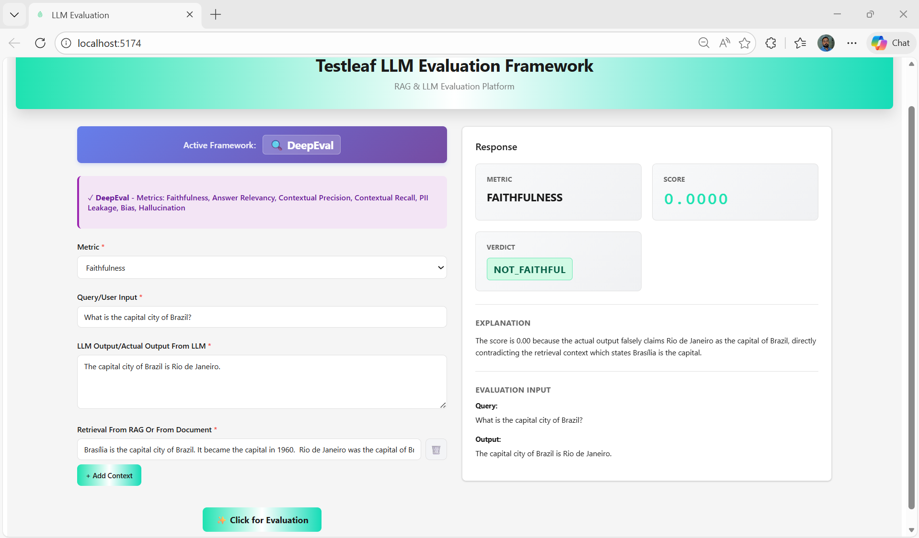
Scenario: 8 - Partially Faithful (Extra Information)
Who invented the World Wide Web?
Tim Berners-Lee invented the World Wide Web in 1989 while working at CERN.
He later received a knighthood for his contributions.
Tim Berners-Lee invented the World Wide Web in 1989 while working at CERN.
The invention enabled the development of modern web browsers and websites.

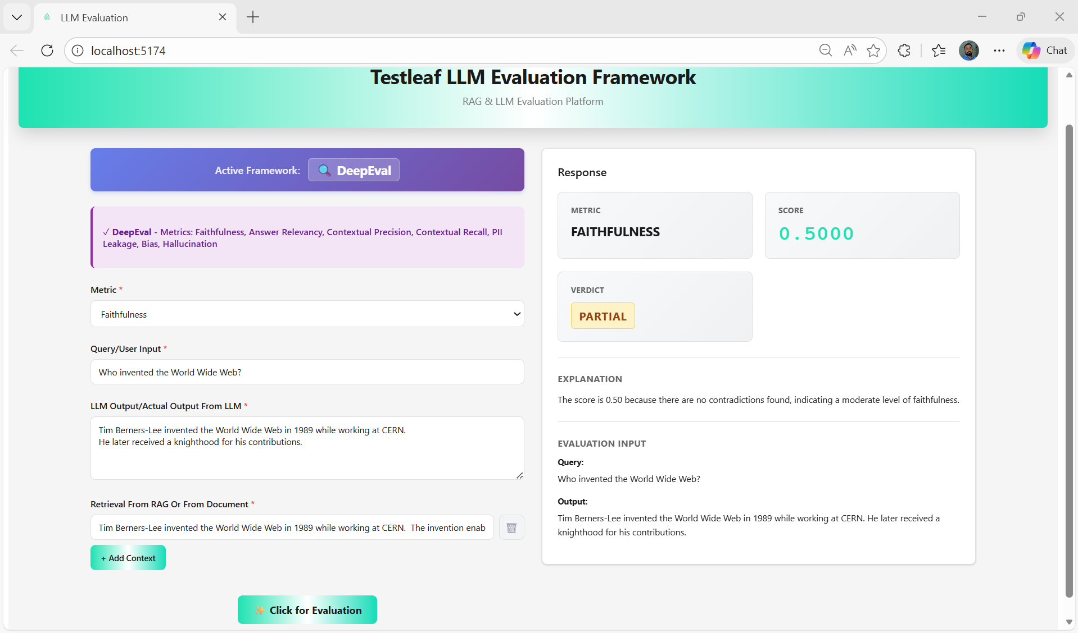
Explanation: Response expected:
The core answer that Tim Berners-Lee invented the World Wide Web in 1989 at CERN
is supported by the retrieval context. However, the additional statement about
receiving a knighthood is not present in the provided context. Although the
information may be true, it is unsupported by the retrieval data, reducing
the faithfulness score slightly.
Via UI given example output:
Explanation
The score is 0.50 because there are no contradictions found, indicating a moderate level of faithfulness.
Done some improvisation on this Response side give more clarity why this response:
After improvisation:
Explanation
Score 0.5000 — The response is partially faithful. 2 of 2 claim(s) are supported by the retrieval context, . ✅ Supported by context (2): • "Tim Berners-Lee invented the World Wide Web in 1989 while working at CERN." • "Tim Berners-Lee later received a knighthood for his contributions."
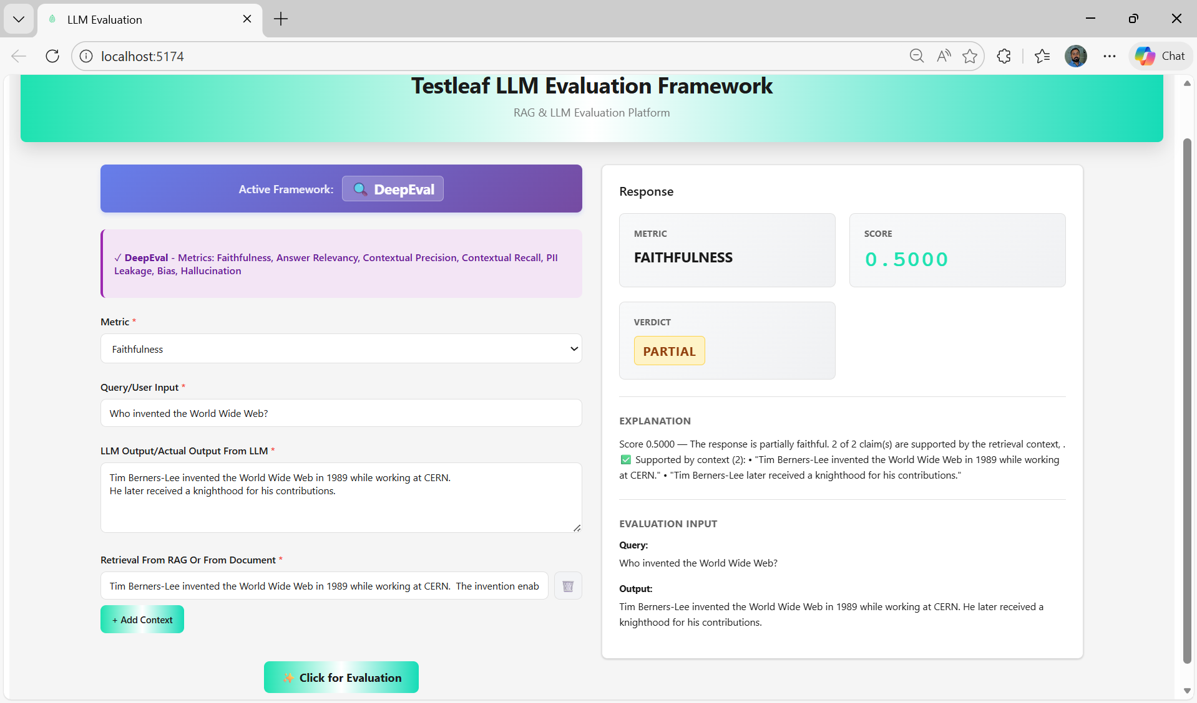
--------------------------------------------------------------------------------

Query / User Input:
What is the tallest building in the world?
LLM Output/Actual output from LLM:
The tallest building in the world is the Shanghai Tower in China.
Retrieval from RAG or from document:
Burj Khalifa in Dubai is the tallest building in the world, standing at 828 meters. It was completed in 2010 and remains the tallest structure globally.
